## Create a pipeline: S3 to S3

**Step 1:**

Sign in to the AWS Management Console and open the CodePipeline

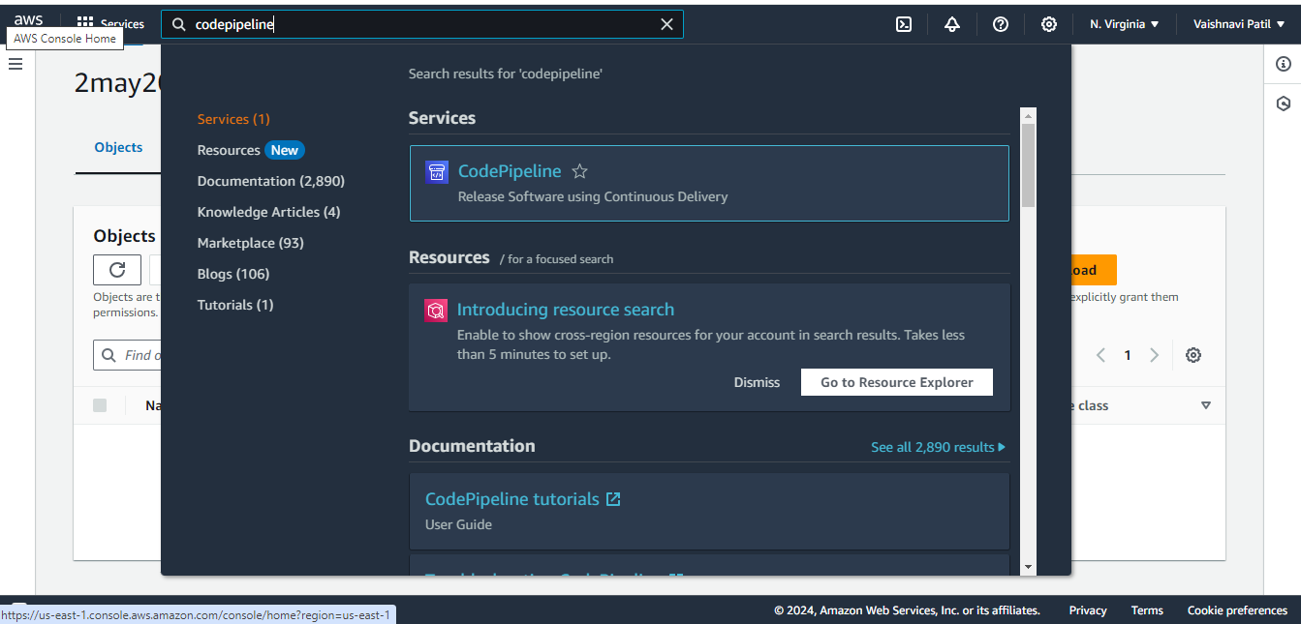

**Step 2:**

On the **Welcome** page, choose **Create pipeline**.

If this is your first time using CodePipeline, choose **Get Started**.

**Step 3:**

**Choose pipeline settings** page,

1. In **Pipeline name**, enter the name for your pipeline.

In a single AWS account, each pipeline you create in an AWS Region must have

unique name. Names can be reused for pipelines in different Regions

1. In **Pipeline type**, choose one of the following options. Pipeline types differ in characteristics and price. For more information, see [Pipeline types](https://docs.aws.amazon.com/codepipeline/latest/userguide/pipeline-types.html).
   * **V1** type pipelines have a JSON structure that contains standard pipeline, stage, and action-level parameters.
   * **V2** type pipelines have the same structure as a V1 type, along with additional parameter support, such as triggers on Git tags and pipeline-level variables.

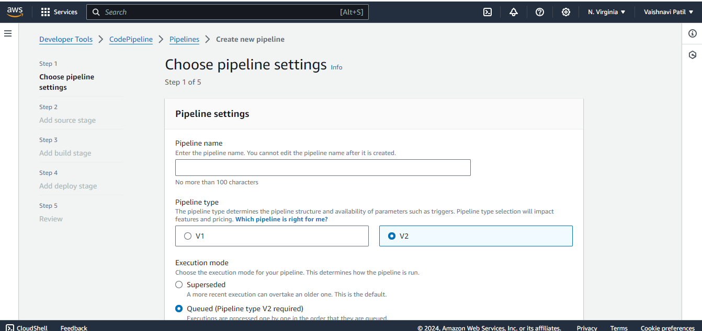

3. In **Service role**, do one of the following:

* Choose **New service role** to allow CodePipeline to create a new service role in IAM.
* Choose **Existing service role** to use a service role already created in IAM. In **Role ARN**, choose your service role ARN from the list.

Under **Variables**, choose **Add variable** to add variables at the pipeline level.

For more information about variables at the pipeline level, see [Variables](https://docs.aws.amazon.com/codepipeline/latest/userguide/reference-variables.html). For a tutorial with a pipeline-level variable that is passed at the time of the pipeline execution

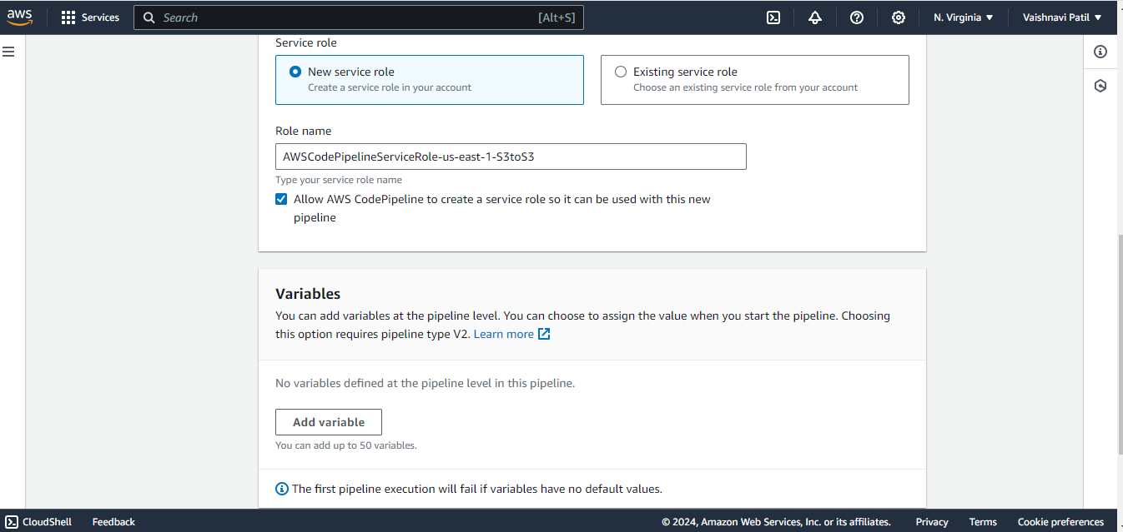

1. Expand **Advanced settings**.

In **Artifact store**, do one of the following:

1. Choose **Default location** to use the default artifact store, such as the S3 artifact bucket designated as the default, for your pipeline in the AWS Region you have selected for your pipeline.
2. Choose **Custom location** if you already have an artifact store, such as an S3 artifact bucket, in the same Region as your pipeline. In **Bucket**, choose the bucket name

In **Encryption key**, do one of the following:

1. To use the CodePipeline default AWS KMS key to encrypt the data in the pipeline artifact store (S3 bucket), choose **Default AWS Managed Key**.
2. To use your customer managed key to encrypt the data in the pipeline artifact store (S3 bucket), choose **Customer Managed Key**. Choose the key ID, key ARN, or alias ARN.
3. Choose **Next**.

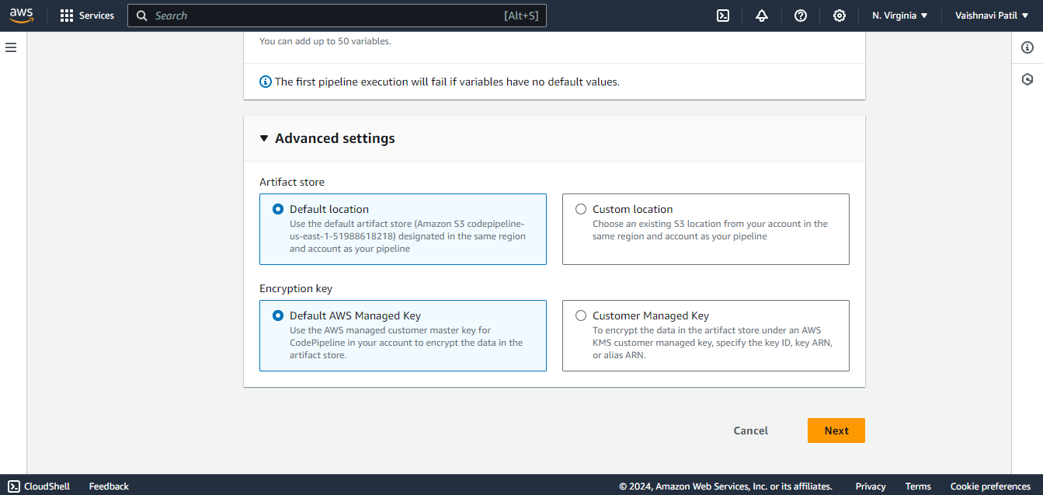

###### **Step 4:** Create a source stage

1. **Add source stage** page, in **Source provider**, choose the type of repository where your source code is stored, specify its required options, and then choose **Next step**.
2. Enter the bucket name and S3 object key.
3. Accept the defaults under **Change detection options**. This allows CodePipeline to use Amazon CloudWatch Events and AWS CloudTrail to detect changes for your new pipeline. Choose **Next**.

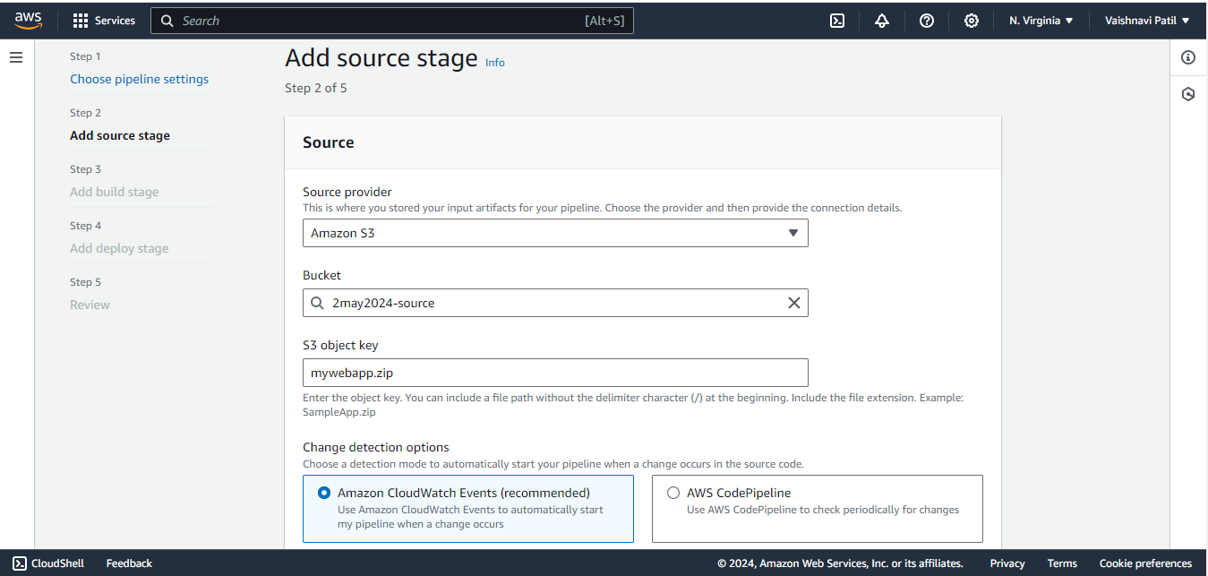

**Step 5:** Create a build stage.

Choose **Skip build stage** if you plan to create a deployment stage.

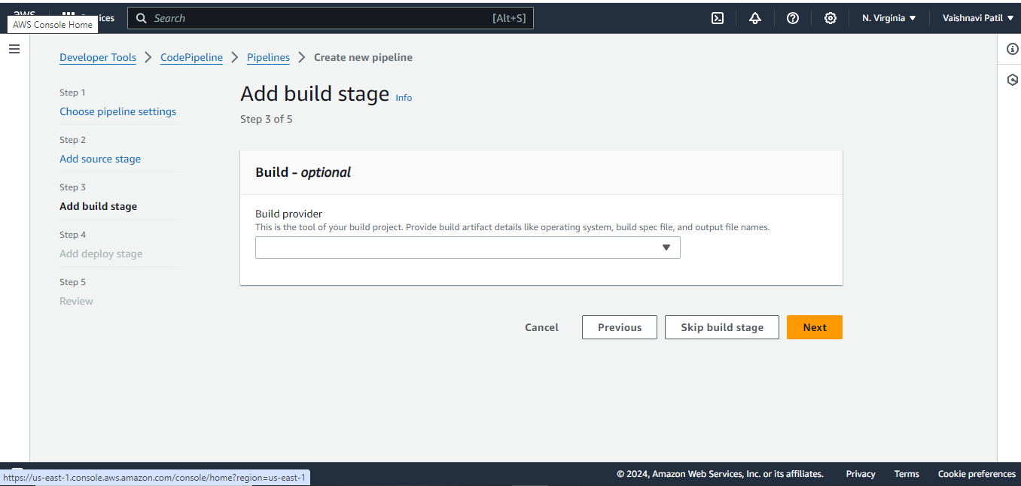

###### **Step 6:** Create a deployment stage.

* In **Deploy provider**, choose a custom action that you have created for a deployment provider.
* In **Region**, for cross-Region actions only, choose the AWS Region where the resource is created.
* Add bucket name

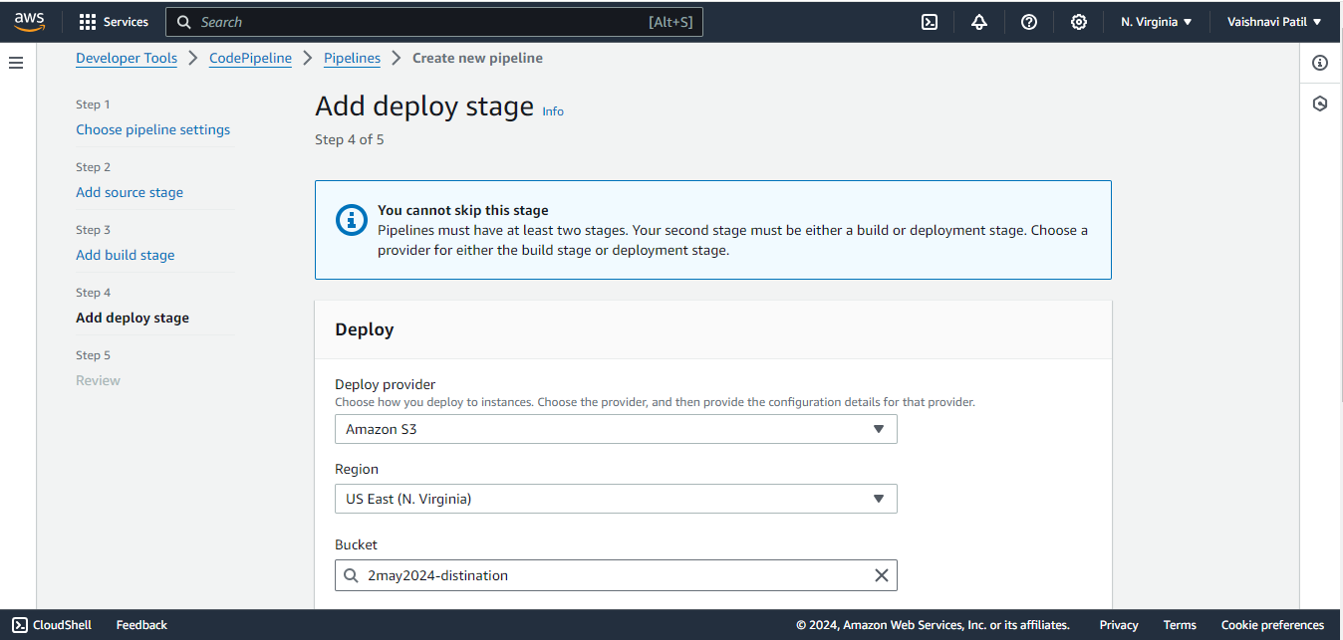

Additional configuration

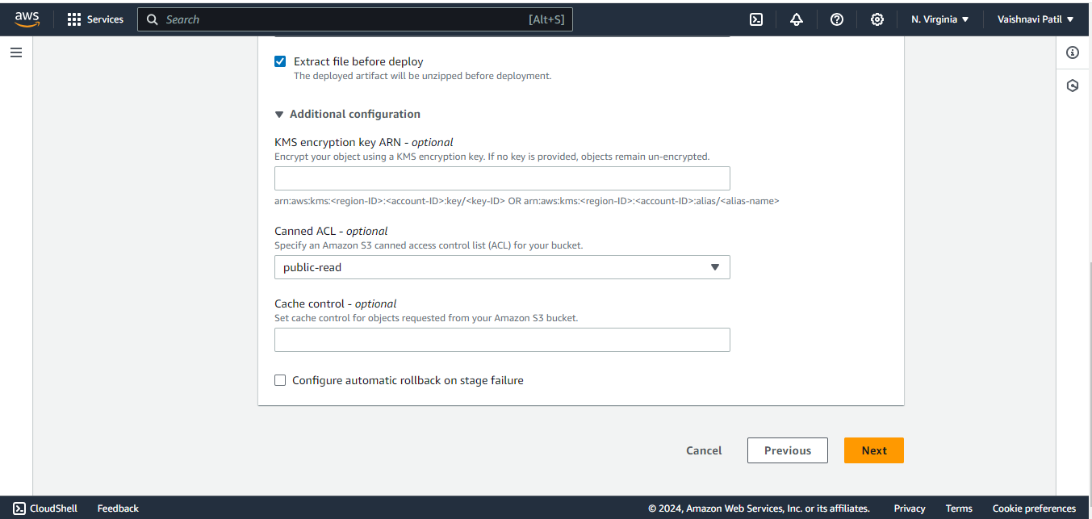

###### **Step 7:** Review the pipeline

* **Review** page, review your pipeline configuration, and then choose **Create pipeline** to create the pipeline or **Previous** to go back and edit your choices. To exit the wizard without creating a pipeline, choose **Cancel**.

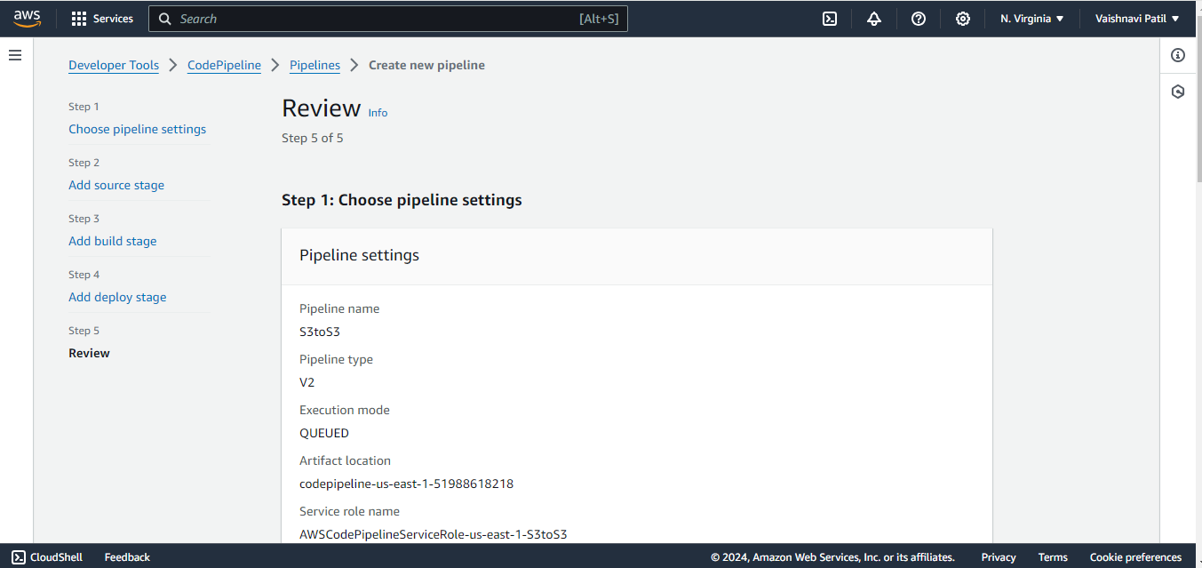

**Step 8:** Codepipeline is successfully created**.**

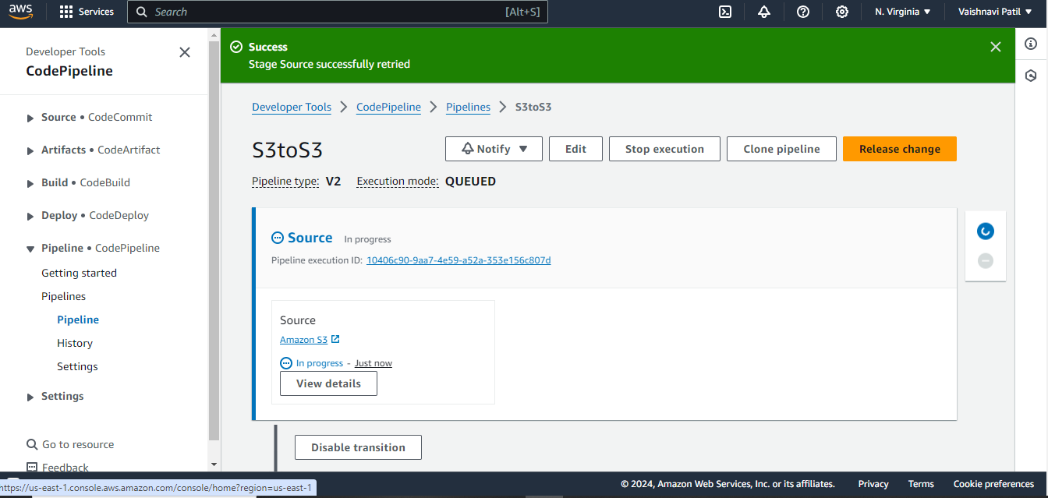

**Step 9:** Open the created distination bucket and copy the static website hosting URL.

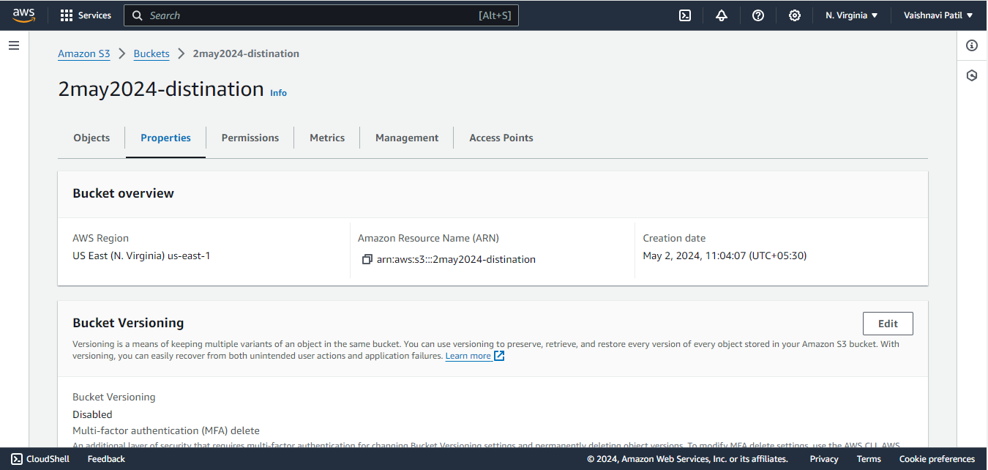

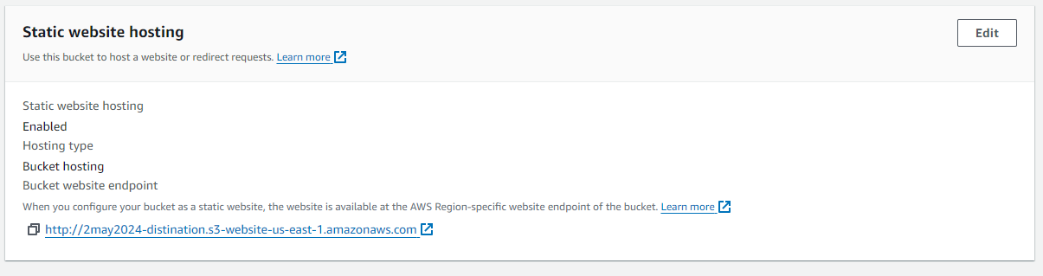

**Step 10:** Paste the URL in static website hosting in chrome and then see the result.

